

**Project Report**

**Hospital Network Design**

**Course Title - Computer Network Lab**

**Course Code - CSE 416**

**Submitted to**

Momtaj Hossain Mow

Lecturer

Eastern University

**Submitted by**

Name: Jannatul Firdous Samiya

ID: 222400024

Department of CSE

**Introduction**

This project focuses on designing a structured and scalable **Hospital Network System** using **Cisco Packet Tracer**. The goal is to ensure **reliable communication**, **secure data sharing**, and **efficient resource access** across different hospital departments including IT, Clinical, General and Private Wards, and Reception.

**Network Zones**

The hospital network is logically divided into several subnet-based departments:

| **Department** | **Subnet** |
| --- | --- |
| IT Department | 192.168.1.0/24 |
| Clinical Area | 192.168.2.0/24 |
| Entrance Reception | 192.168.3.0/24 |
| General Ward | 192.168.4.0/24 |
| Private Ward | 192.168.5.0/24 |
| Guest Wi-Fi Zone | DHCP-based (Wi-Fi) |

**Devices Used**

* **Routers:** 5 (Router0 to Router4)
* **Switches:** 6 (2960-24TT switches)
* **End Devices:** PCs, Laptops, Smartphones, Tablets
* **Servers:** DNS, HTTP, SMTP, FTP
* **Wireless Router:** WRT300N (for Guests)

**Network Topology Overview**

* **Router0 (IT Department)** connects the IT PCs, servers, and links with Clinical & Reception routers via serial links.
* **Router1 (Clinical)** connects Ultrasound, OT, Rooms, etc.
* **Router2 (General Ward)** connects ward PCs and doctors.
* **Router3 (Private Ward)** connects private ward PCs.
* **Router4 (Entrance)** connects Reception, Info Counter, Billing.
* **WRT300N Router** serves Guest Wi-Fi, isolated from the core hospital LAN.

**IP Addressing**

Each subnet is assigned a unique Class C private network with subnet mask **255.255.255.0**. IPs are statically assigned to routers and PCs.

**Routing Configuration:**

Routing between subnets is achieved using either:

* **Static routing**: Simple for small networks
* or **OSPF dynamic routing**: Recommended for scalability (if implemented)

Each router includes proper routes to reach all subnets.

**Services Configured**

* **DNS Server**: Resolves domain names
* **HTTP Server**: Web-based access
* **SMTP/FTP Server**: Mail and file sharing
* **DHCP**: Likely used for Wi-Fi guest zone

**Connectivity & Testing**

**Successful Communication:**

* IT Dept ↔ Clinical Area
* Clinical ↔ General ↔ Private
* Entrance ↔ IT ↔ Clinical
* Servers accessible within hospital LAN

**Restricted Communication**

* Guest Wi-Fi devices **cannot access** hospital PCs or servers, maintaining **security**.

All connections were tested via **ping**, and each zone communicates successfully if routing is configured properly.

**Limitations & Recommendations**

* **Wi-Fi zone** should be NAT-enabled if internet access is required.
* Add **Access Control Lists (ACLs)** to secure sensitive subnets.
* Consider **VLANs** in future to segment traffic further.

**Network Diagram**

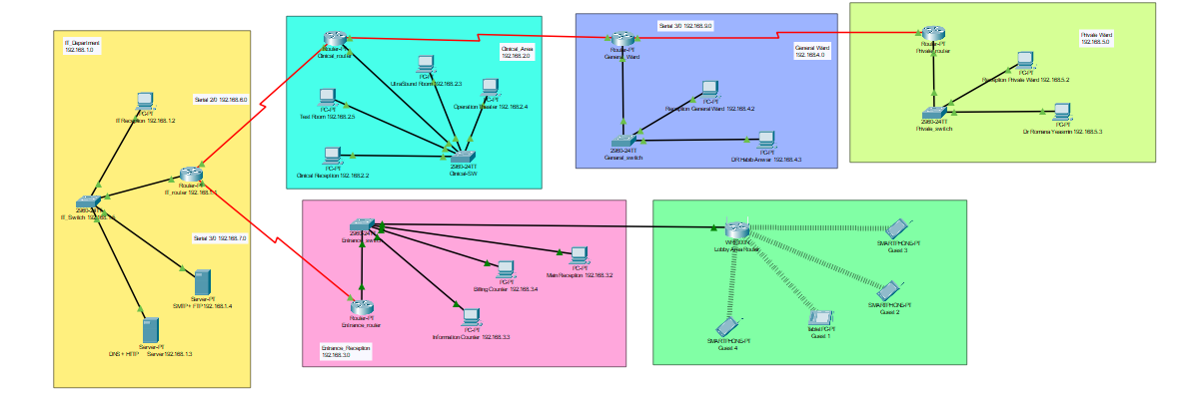

**Conclusion**

This hospital network design demonstrates how a medium-sized organization like a hospital can implement a robust and secure LAN infrastructure using routers, switches, and basic services. Proper segmentation and routing ensure data isolation, internal communication, and service availability.